**Deons Longitudinal Network Analysis**

#Load required packages

library(bootnet)

library(networktools)

library(NetworkComparisonTest)

library(qgraph)

{r echo=FALSE, warning=FALSE, error=FALSE}

Part 1: First Time point

#Load data of first network "Time1" (I just used haven)

#Assign names to the nodes in the first network

names1 <- c("CAS1", "CAS2", "CAS3", "CAS4", "CAS5", "Depression1", "Anxiety1", "Stress1", "Alcoholism1")

#Estimate network using default methods

network1 <- estimateNetwork(Time1, default="EBICglasso")  
  
#group DASS and BSMAS nodes

groups1=list("CAS"=c(1:5), "Comorbidity"=c(6:9))

#Estimate Network Stability by bootstrapping network

b1 <- bootnet(network1, boots=1000, statistics=c("strength", "expectedInfluence", "betweenness", "closeness", "edge"))

b2 <- bootnet(network1, boots=1000, type="case", statistics=c("strength", "expectedInfluence", "betweenness", "closeness", "edge"))

#Get centrality stability coefficient

corStability(b2)

Maximum drop proportions to retain correlation of 0.7 in at least 95% of the samples:

betweenness: 0

- For more accuracy, run bootnet(..., caseMin = 0, caseMax = 0.05)

closeness: 0.362

- For more accuracy, run bootnet(..., caseMin = 0.283, caseMax = 0.439)

edge: 0.75 (CS-coefficient is highest level tested)

- For more accuracy, run bootnet(..., caseMin = 0.673, caseMax = 1)

expectedInfluence: 0.75 (CS-coefficient is highest level tested)

- For more accuracy, run bootnet(..., caseMin = 0.673, caseMax = 1)

strength: 0.75 (CS-coefficient is highest level tested)

- For more accuracy, run bootnet(..., caseMin = 0.673, caseMax = 1)

Accuracy can also be increased by increasing both 'nBoots' and 'caseN'

#Save centrality stability graphs

pdf("CentrStability1.pdf")

plot(b2)

dev.off()

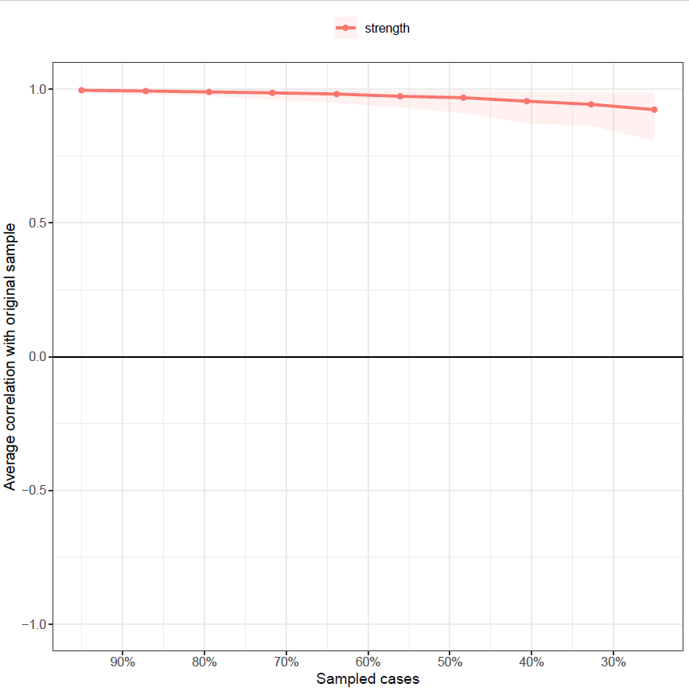

pdf("ExpectStability1.pdf")

plot(b2, “expectedInfluence”)

dev.off()

pdf("betweenStability1.pdf")

plot(b2, "betweenness")  
dev.off()

pdf("closeStability1.pdf")

plot(b2, "closeness")

dev.off()

#Strength Centrality Diff Test, saved as pdf

pdf("CentralityDifference1.pdf")

plot(b1, "strength", order="sample", labels=TRUE)

dev.off()

#Expected Influence Centrality Diff Test, saved as pdf

pdf("ExpectedDifference1.pdf")

plot(b1, "expectedInfluence", order="sample", labels=TRUE)

dev.off()

#Edge Stability Graph saved as pdf

pdf("EdgeStability1.pdf")

plot(b1, labels = FALSE, order = "sample")

dev.off()

#Edge weights stability test saved as pdf

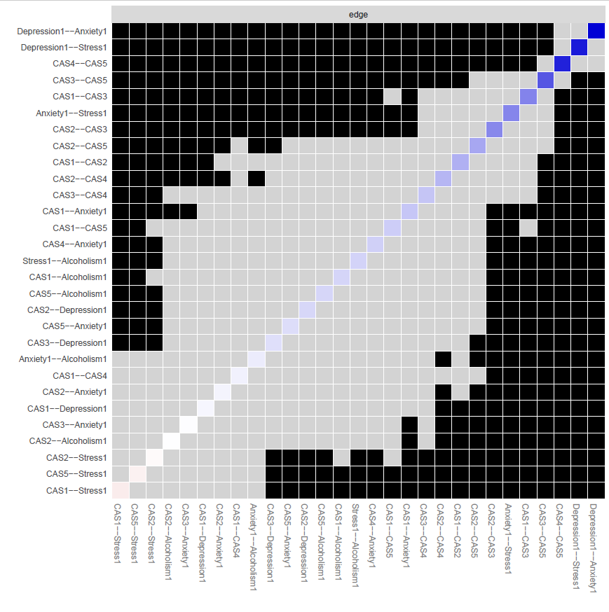pdf("EdgeDifftest1.pdf")

plot(b1, "edge", plot="difference", onlyNonZero=TRUE, order = "sample")

dev.off()

#create strength/EI centrality plots and save as pdf

pdf("EDPlot1.pdf", width=5)

c1 <- centralityPlot(network1, include = c("ExpectedInfluence"), orderBy ="default")

dev.off()

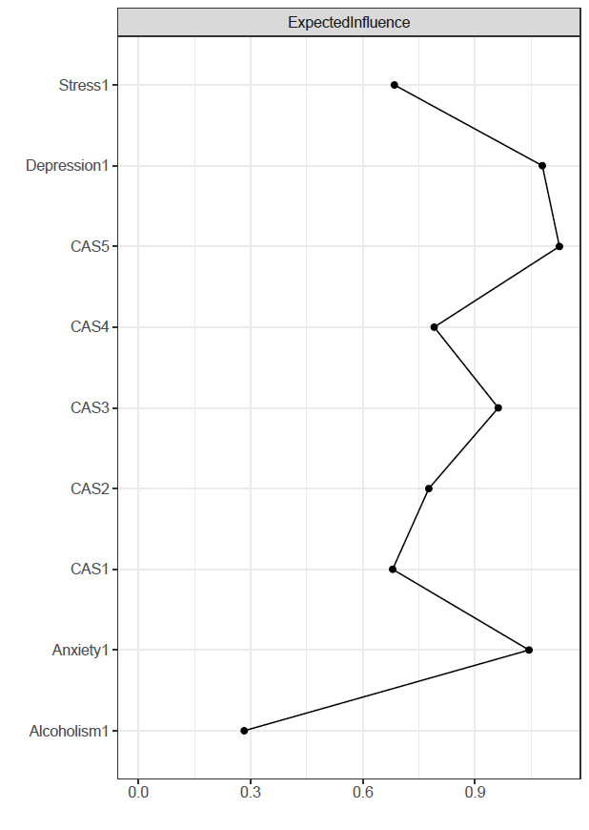

pdf("CentralityPlot1.pdf", width=5)

c2 <- centralityPlot(network1, include = c("Betweenness", "Closeness"), orderBy ="default")

dev.off()

#create a plot featuring these groups and make it a pdf

pdf("plot1.pdf")

plot1 <- plot(network1, layout="spring", vsize=6, border.color="black", groups=groups1, color=c('lightblue', 'orange'))

dev.off()

#save centrality values as a excel file

Centrality1 <- centralityTable(network1)

write.csv(Centrality1, "Centrality1.csv")

|  |  |  |  |  |  |
| --- | --- | --- | --- | --- | --- |
|  | graph | type | node | measure | value |
| 1 | graph 1 | NA | CAS1 | Betweenness | 0.089287 |
| 2 | graph 1 | NA | CAS2 | Betweenness | -1.11608 |
| 3 | graph 1 | NA | CAS3 | Betweenness | -0.3125 |
| 4 | graph 1 | NA | CAS4 | Betweenness | 0.089287 |
| 5 | graph 1 | NA | CAS5 | Betweenness | 0.892866 |
| 6 | graph 1 | NA | Depression1 | Betweenness | -0.3125 |
| 7 | graph 1 | NA | Anxiety1 | Betweenness | 2.098235 |
| 8 | graph 1 | NA | Stress1 | Betweenness | -0.3125 |
| 9 | graph 1 | NA | Alcoholism1 | Betweenness | -1.11608 |
| 10 | graph 1 | NA | CAS1 | Closeness | 1.178384 |
| 11 | graph 1 | NA | CAS2 | Closeness | -0.04411 |
| 12 | graph 1 | NA | CAS3 | Closeness | 0.575025 |
| 13 | graph 1 | NA | CAS4 | Closeness | 0.626618 |
| 14 | graph 1 | NA | CAS5 | Closeness | 0.760244 |
| 15 | graph 1 | NA | Depression1 | Closeness | -0.11305 |
| 16 | graph 1 | NA | Anxiety1 | Closeness | 0.083603 |
| 17 | graph 1 | NA | Stress1 | Closeness | -0.99204 |
| 18 | graph 1 | NA | Alcoholism1 | Closeness | -2.07468 |
| 19 | graph 1 | NA | CAS1 | Strength | -0.4026 |
| 20 | graph 1 | NA | CAS2 | Strength | -0.23992 |
| 21 | graph 1 | NA | CAS3 | Strength | 0.400973 |
| 22 | graph 1 | NA | CAS4 | Strength | -0.25262 |
| 23 | graph 1 | NA | CAS5 | Strength | 1.23051 |
| 24 | graph 1 | NA | Depression1 | Strength | 0.850162 |
| 25 | graph 1 | NA | Anxiety1 | Strength | 0.71428 |
| 26 | graph 1 | NA | Stress1 | Strength | -0.11073 |
| 27 | graph 1 | NA | Alcoholism1 | Strength | -2.19006 |
| 28 | graph 1 | NA | CAS1 | ExpectedInfluence | -0.54936 |
| 29 | graph 1 | NA | CAS2 | ExpectedInfluence | -0.18439 |
| 30 | graph 1 | NA | CAS3 | ExpectedInfluence | 0.517657 |
| 31 | graph 1 | NA | CAS4 | ExpectedInfluence | -0.12965 |
| 32 | graph 1 | NA | CAS5 | ExpectedInfluence | 1.135268 |
| 33 | graph 1 | NA | Depression1 | ExpectedInfluence | 0.962522 |
| 34 | graph 1 | NA | Anxiety1 | ExpectedInfluence | 0.827948 |
| 35 | graph 1 | NA | Stress1 | ExpectedInfluence | -0.53156 |
| 36 | graph 1 | NA | Alcoholism1 | ExpectedInfluence | -2.04844 |

#construct a partial correlation matrix

edges1<-getWmat(network1)

write.csv(edges1, "edges1.csv")

|  |  |  |  |  |  |  |  |  |  |
| --- | --- | --- | --- | --- | --- | --- | --- | --- | --- |
|  | CAS1 | CAS2 | CAS3 | CAS4 | CAS5 | Depression1 | Anxiety1 | Stress1 | Alcoholism1 |
| CAS1 | 0 | 0.150729 | 0.23698 | 0.027253 | 0.095103 | 0.016762 | 0.108012 | -0.0359 | 0.080776 |
| CAS2 | 0.150729 | 0 | 0.227815 | 0.138738 | 0.167334 | 0.077202 | 0.020899 | -0.00891 | 0.00254 |
| CAS3 | 0.23698 | 0.227815 | 0 | 0.110415 | 0.322414 | 0.060769 | 0.003823 | 0 | 0 |
| CAS4 | 0.027253 | 0.138738 | 0.110415 | 0 | 0.423948 | 0 | 0.090484 | 0 | 0 |
| CAS5 | 0.095103 | 0.167334 | 0.322414 | 0.423948 | 0 | 0 | 0.064811 | -0.027 | 0.079116 |
| Depression1 | 0.016762 | 0.077202 | 0.060769 | 0 | 0 | 0 | 0.487182 | 0.438081 | 0 |
| Anxiety1 | 0.108012 | 0.020899 | 0.003823 | 0.090484 | 0.064811 | 0.487182 | 0 | 0.233457 | 0.035698 |
| Stress1 | -0.0359 | -0.00891 | 0 | 0 | -0.027 | 0.438081 | 0.233457 | 0 | 0.084699 |
| Alcoholism1 | 0.080776 | 0.00254 | 0 | 0 | 0.079116 | 0 | 0.035698 | 0.084699 | 0 |

#Estimate bridge Values for each node

bridge(plot1, communities=c('1', '1', '1', '1', '1', '2', '2', '2', '2'), useCommunities = "all", directed = NULL, nodes = NULL)

$`Bridge Strength`

CAS1 CAS2 CAS3 CAS4 CAS5 Depression1

0.24144857 0.10955352 0.06459161 0.09048423 0.17092489 0.15473282

Anxiety1 Stress1 Alcoholism1

0.28802940 0.07180778 0.16243282

$`Bridge Betweenness`

CAS1 CAS2 CAS3 CAS4 CAS5 Depression1

3 0 0 3 3 2

Anxiety1 Stress1 Alcoholism1

8 0 0

$`Bridge Closeness`

CAS1 CAS2 CAS3 CAS4 CAS5 Depression1

0.08603876 0.06471428 0.06398839 0.07340877 0.06755962 0.07314015

Anxiety1 Stress1 Alcoholism1

0.08038064 0.06283943 0.06722714

$`Bridge Expected Influence (1-step)`

CAS1 CAS2 CAS3 CAS4 CAS5 Depression1

0.16965207 0.09172866 0.06459161 0.09048423 0.11693068 0.15473282

Anxiety1 Stress1 Alcoholism1

0.28802940 -0.07180778 0.16243282

$`Bridge Expected Influence (2-step)`

CAS1 CAS2 CAS3 CAS4 CAS5 Depression1

0.29215198 0.24493990 0.23250216 0.23297495 0.24572878 0.37954881

Anxiety1 Stress1 Alcoholism1

0.55403206 0.02533127 0.28938563

$communities

[1] "1" "1" "1" "1" "1" "2" "2" "2" "2"

#Set Bridge estimates as an object

bridge1 <- bridge(plot1, communities=c('1', '1', '1', '1', '1', '2', '2', '2', '2'), useCommunities = "all", directed = NULL, nodes = NULL)

#Create bridge expected influence graph and save as a pdf

pdf("bridgeEI1.pdf, width=5")

plot(bridge1, include = "Bridge Expected Influence (1-step)", width = 5)

dev.off()

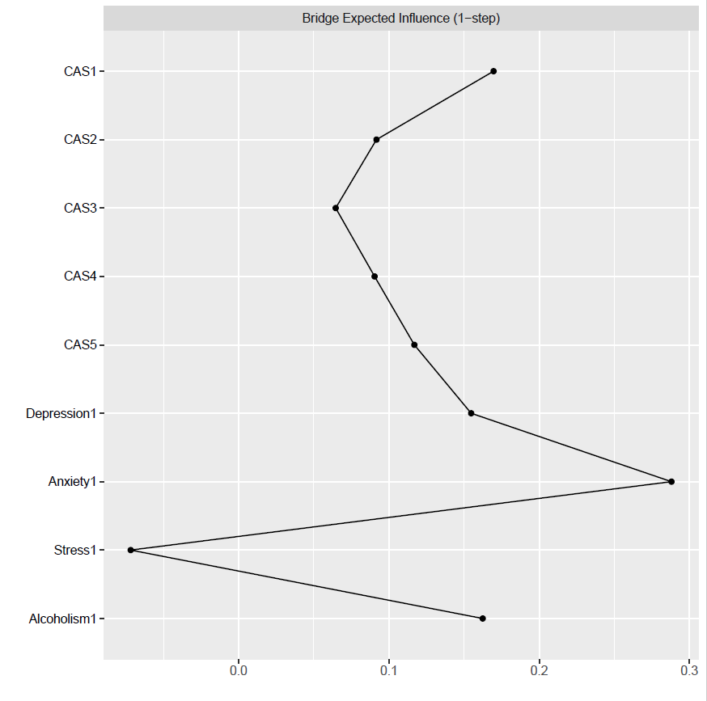

#Create an object for the Stability estimates of bridges

bridgestability1 <- bootnet(network1, boots=1000, type="case", statistics=c("bridgeStrength", "bridgeExpectedInfluence", "bridgeBetweenness", "bridgeCloseness"), communities=groups1)

#get stability coefficients of that networks bridges

corStability(bridgestability1)

Maximum drop proportions to retain correlation of 0.7 in at least 95% of the samples:

bridgeBetweenness: 0.05 (CS-coefficient is lowest level tested)

- For more accuracy, run bootnet(..., caseMin = 0, caseMax = 0.128)

bridgeCloseness: 0.05 (CS-coefficient is lowest level tested)

- For more accuracy, run bootnet(..., caseMin = 0, caseMax = 0.128)

bridgeExpectedInfluence: 0.594

- For more accuracy, run bootnet(..., caseMin = 0.517, caseMax = 0.673)

bridgeStrength: 0.362

- For more accuracy, run bootnet(..., caseMin = 0.283, caseMax = 0.439)

Accuracy can also be increased by increasing both 'nBoots' and 'caseN'.

#And we're done with the first Network! Time to move on to number two!

Part 2: Second Time point

#Load data of second network "Time2" (I just used haven)

#Assign names to the nodes in the second network

names2 <- c("CAS1_2", "CAS2_2", "CAS3_2", "CAS4_2", "CAS5_2", "Depression2", "Anxiety2", "Stress2", "Alcoholism2")

#Estimate network using default methods

network2 <- estimateNetwork(Time2, default="EBICglasso")

#group DASS and BSMAS nodes

groups2=list("CAS"=c(1:5), "Comorbidity"=c(6:9))

#Estimate Network Stability by bootstrapping network

b3 <- bootnet(network2, boots=1000, statistics=c("strength", "expectedInfluence", "betweenness", "closeness", "edge"))

b4 <- bootnet(network2, boots=1000, type="case", statistics=c("strength", "expectedInfluence", "betweenness", "closeness", "edge"))

#Get centrality stability coefficient

corStability(b4)

Maximum drop proportions to retain correlation of 0.7 in at least 95% of the samples:

betweenness: 0.05 (CS-coefficient is lowest level tested)

- For more accuracy, run bootnet(..., caseMin = 0, caseMax = 0.128)

closeness: 0.128

- For more accuracy, run bootnet(..., caseMin = 0.05, caseMax = 0.206)

edge: 0.673

- For more accuracy, run bootnet(..., caseMin = 0.594, caseMax = 0.75)

expectedInfluence: 0.75 (CS-coefficient is highest level tested)

- For more accuracy, run bootnet(..., caseMin = 0.673, caseMax = 1)

strength: 0.673

- For more accuracy, run bootnet(..., caseMin = 0.594, caseMax = 0.75)

Accuracy can also be increased by increasing both 'nBoots' and 'caseN'.

#Save centrality stability graphs

pdf("CentrStability2.pdf")

plot(b4)

dev.off()

pdf("ExpectStability2.pdf")

plot(b4, “expectedInfluence”)

dev.off()

pdf("betweenStability2.pdf")

plot(b4, "betweenness")  
dev.off()

pdf("closeStability2.pdf")

plot(b4, "closeness")

dev.off()

#Strength Centrality Diff Tests, saved as pdf

pdf("CentralityDifference2.pdf")

plot(b3, "strength", order="sample", labels=TRUE)

dev.off()

#Expected INfluence stability graph saved as pdf - Unneccessary

pdf("EIdifference2.pdf")

plot(b3, "expectedInfluence", order="sample", labels=TRUE)

dev.off()

#Edge Stability Graph saved as pdf

pdf("EdgeStability2.pdf")

plot(b3, labels = FALSE, order = "sample")

dev.off()

#Edge weights stability test saved as pdf

pdf("EdgeDifftest2.pdf")

plot(b3, "edge", plot="difference", onlyNonZero=TRUE, order = "sample")

dev.off()

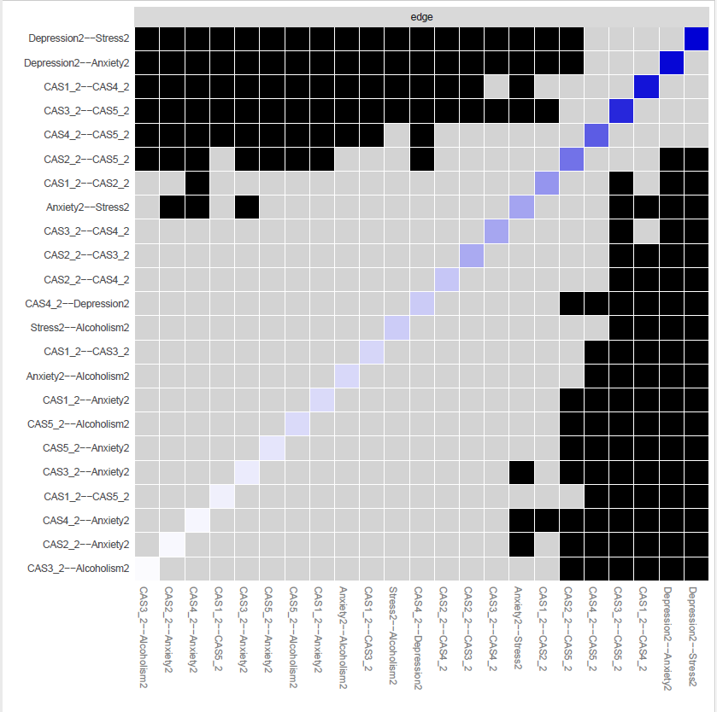

#Save plot as a pdf with groups into set directory

pdf("plot2.pdf")

plot2 <- plot(network2, layout="spring", vsize=6, border.color="black", groups=groups2, color=c('lightblue', 'orange'))

dev.off()

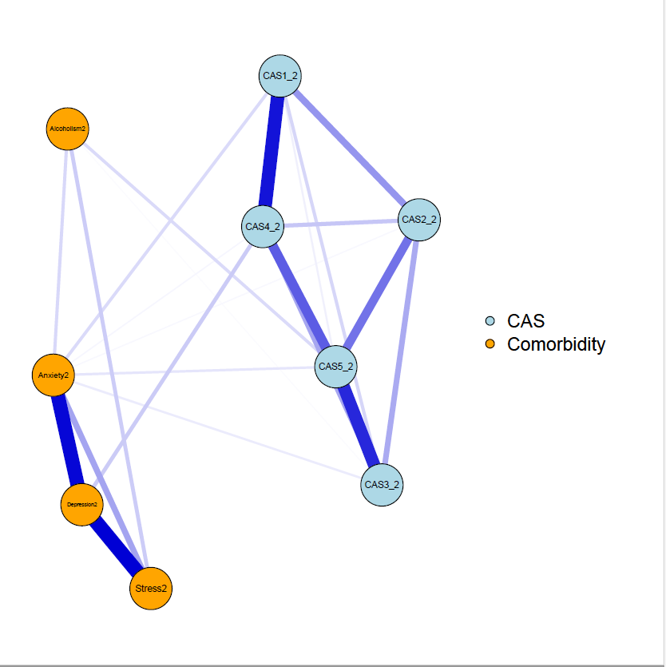

#create centrality plot and save as pdf

pdf("CentralityPlot2.pdf", width=5)

c2 <- centralityPlot(plot2)

dev.off()

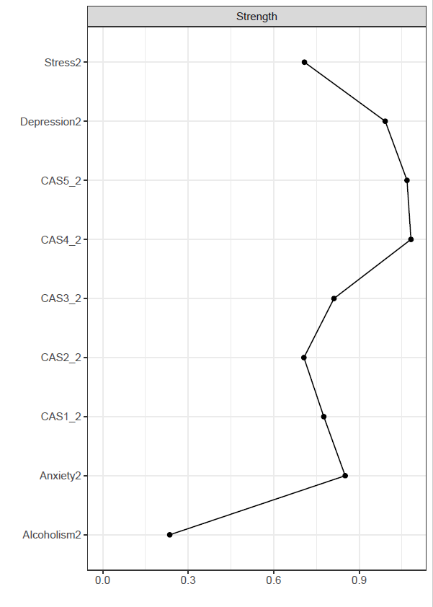

#Create Expected influence plot and save as pdf (Unnecessary given the lack of negative edges)

pdf("ExpectedInfluence2.pdf", width=5)

e2 <- centralityPlot(plot2, include = "ExpectedInfluence")

dev.off()

#Create Betweenness/Closeness plot and save as a pdf.

pdf("BetClosePlot2.pdf", width=5)

c3 <- centralityPlot(network2, include = c("Betweenness", "Closeness"), orderBy ="default")

dev.off()

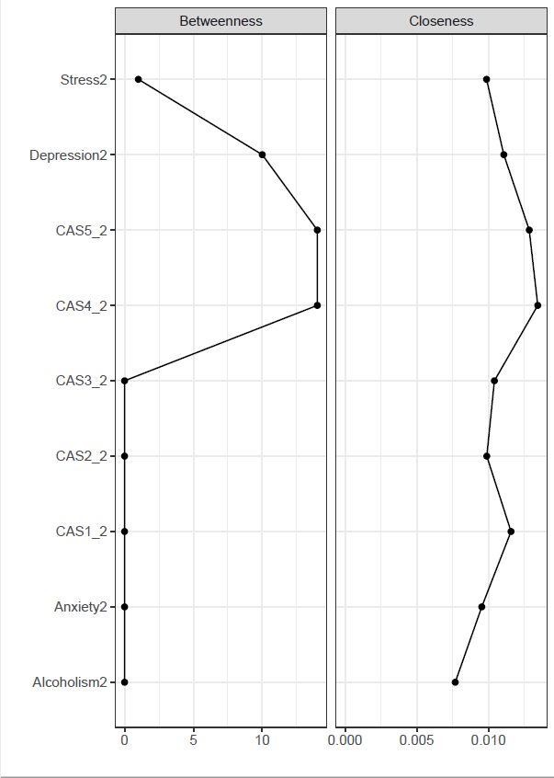

#save centrality values as a excel file

Centrality2 <- centralityTable(network2)

write.csv(Centrality2, "Centrality2.csv")

|  |  |  |  |  |  |
| --- | --- | --- | --- | --- | --- |
|  | graph | type | node | measure | value |
| 1 | graph 1 | NA | CAS1_2 | Betweenness | -0.68092 |
| 2 | graph 1 | NA | CAS2_2 | Betweenness | -0.68092 |
| 3 | graph 1 | NA | CAS3_2 | Betweenness | -0.68092 |
| 4 | graph 1 | NA | CAS4_2 | Betweenness | 1.51897 |
| 5 | graph 1 | NA | CAS5_2 | Betweenness | 1.51897 |
| 6 | graph 1 | NA | Depression2 | Betweenness | 0.890431 |
| 7 | graph 1 | NA | Anxiety2 | Betweenness | -0.68092 |
| 8 | graph 1 | NA | Stress2 | Betweenness | -0.52378 |
| 9 | graph 1 | NA | Alcoholism2 | Betweenness | -0.68092 |
| 10 | graph 1 | NA | CAS1_2 | Closeness | 0.494399 |
| 11 | graph 1 | NA | CAS2_2 | Closeness | -0.46336 |
| 12 | graph 1 | NA | CAS3_2 | Closeness | -0.16234 |
| 13 | graph 1 | NA | CAS4_2 | Closeness | 1.551426 |
| 14 | graph 1 | NA | CAS5_2 | Closeness | 1.215302 |
| 15 | graph 1 | NA | Depression2 | Closeness | 0.209399 |
| 16 | graph 1 | NA | Anxiety2 | Closeness | -0.66229 |
| 17 | graph 1 | NA | Stress2 | Closeness | -0.47222 |
| 18 | graph 1 | NA | Alcoholism2 | Closeness | -1.71031 |
| 19 | graph 1 | NA | CAS1_2 | Strength | -0.10646 |
| 20 | graph 1 | NA | CAS2_2 | Strength | -0.37817 |
| 21 | graph 1 | NA | CAS3_2 | Strength | 0.032898 |
| 22 | graph 1 | NA | CAS4_2 | Strength | 1.084816 |
| 23 | graph 1 | NA | CAS5_2 | Strength | 1.031055 |
| 24 | graph 1 | NA | Depression2 | Strength | 0.733457 |
| 25 | graph 1 | NA | Anxiety2 | Strength | 0.185862 |
| 26 | graph 1 | NA | Stress2 | Strength | -0.37112 |
| 27 | graph 1 | NA | Alcoholism2 | Strength | -2.21234 |
| 28 | graph 1 | NA | CAS1_2 | ExpectedInfluence | -0.10646 |
| 29 | graph 1 | NA | CAS2_2 | ExpectedInfluence | -0.37817 |
| 30 | graph 1 | NA | CAS3_2 | ExpectedInfluence | 0.032898 |
| 31 | graph 1 | NA | CAS4_2 | ExpectedInfluence | 1.084816 |
| 32 | graph 1 | NA | CAS5_2 | ExpectedInfluence | 1.031055 |
| 33 | graph 1 | NA | Depression2 | ExpectedInfluence | 0.733457 |
| 34 | graph 1 | NA | Anxiety2 | ExpectedInfluence | 0.185862 |
| 35 | graph 1 | NA | Stress2 | ExpectedInfluence | -0.37112 |
| 36 | graph 1 | NA | Alcoholism2 | ExpectedInfluence | -2.21234 |

#construct a partial correlation matrix

edges2<-getWmat(network2)

write.csv(edges2, "edges2.csv")

|  |  |  |  |  |  |  |  |  |  |
| --- | --- | --- | --- | --- | --- | --- | --- | --- | --- |
|  | CAS1_2 | CAS2_2 | CAS3_2 | CAS4_2 | CAS5_2 | Depression2 | Anxiety2 | Stress2 | Alcoholism2 |
| CAS1_2 | 0 | 0.188526 | 0.072898 | 0.421014 | 0.027251 | 0 | 0.065909 | 0 | 0 |
| CAS2_2 | 0.188526 | 0 | 0.151646 | 0.101945 | 0.251802 | 0 | 0.011935 | 0 | 0 |
| CAS3_2 | 0.072898 | 0.151646 | 0 | 0.157909 | 0.385369 | 0 | 0.035604 | 0 | 0.007943 |
| CAS4_2 | 0.421014 | 0.101945 | 0.157909 | 0 | 0.291118 | 0.09344 | 0.015953 | 0 | 0 |
| CAS5_2 | 0.027251 | 0.251802 | 0.385369 | 0.291118 | 0 | 0 | 0.046198 | 0 | 0.06584 |
| Depression2 | 0 | 0 | 0 | 0.09344 | 0 | 0 | 0.443407 | 0.454345 | 0 |
| Anxiety2 | 0.065909 | 0.011935 | 0.035604 | 0.015953 | 0.046198 | 0.443407 | 0 | 0.161837 | 0.069789 |
| Stress2 | 0 | 0 | 0 | 0 | 0 | 0.454345 | 0.161837 | 0 | 0.091484 |
| Alcoholism2 | 0 | 0 | 0.007943 | 0 | 0.06584 | 0 | 0.069789 | 0.091484 | 0 |

#Estimate bridge Values for each node

bridge(plot2, communities=c('1', '1', '1', '1', '1', '2', '2', '2', '2'), useCommunities = "all", directed = NULL, nodes = NULL)

$`Bridge Strength`

CAS1_2 CAS2_2 CAS3_2 CAS4_2 CAS5_2 Depression2

0.06590950 0.01193476 0.04354735 0.10939341 0.11203869 0.09344018

Anxiety2 Stress2 Alcoholism2

0.17560037 0.00000000 0.07378317

$`Bridge Betweenness`

CAS1_2 CAS2_2 CAS3_2 CAS4_2 CAS5_2 Depression2

0 0 0 12 10 9

Anxiety2 Stress2 Alcoholism2

0 0 0

$`Bridge Closeness`

CAS1_2 CAS2_2 CAS3_2 CAS4_2 CAS5_2 Depression2

0.06386330 0.05144030 0.05537090 0.07545356 0.06469682 0.07112672

Anxiety2 Stress2 Alcoholism2

0.06117283 0.06124341 0.05511693

$`Bridge Expected Influence (1-step)`

CAS1_2 CAS2_2 CAS3_2 CAS4_2 CAS5_2 Depression2

0.06590950 0.01193476 0.04354735 0.10939341 0.11203869 0.09344018

Anxiety2 Stress2 Alcoholism2

0.17560037 0.00000000 0.07378317

$`Bridge Expected Influence (2-step)`

CAS1_2 CAS2_2 CAS3_2 CAS4_2 CAS5_2 Depression2

0.16493448 0.07838435 0.13592750 0.27250696 0.20727198 0.26212515

Anxiety2 Stress2 Alcoholism2

0.36422746 0.07762270 0.15504997

#Set Bridge estimates as an object

bridge2 <- bridge(plot2, communities=c('1', '1', '1', '1', '1', '2', '2', '2', '2'), useCommunities = "all", directed = NULL, nodes = NULL)

#Create bridge expected influence graph and save as a pdf

pdf("bridgeEI2.pdf, width=5")

plot(bridge2, include = "Bridge Expected Influence (1-step)", width = 5)

dev.off()

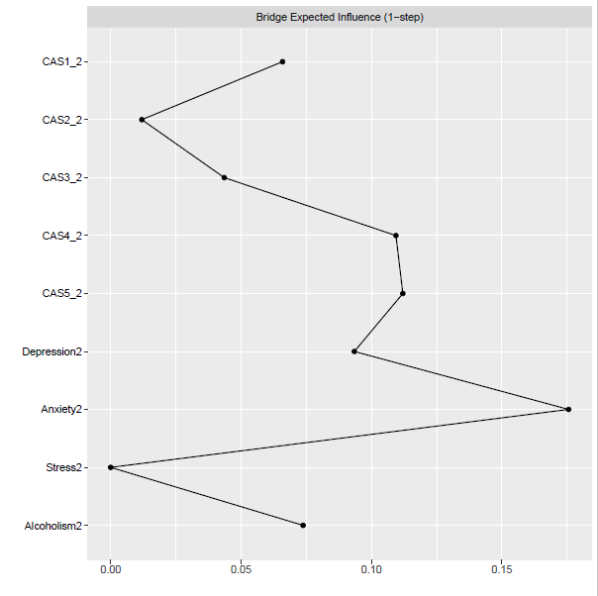

#Create an object for the Stability estimates of bridges

bridgestability2 <- bootnet(network2, boots=1000, type="case", statistics=c("bridgeStrength", "bridgeExpectedInfluence", "bridgeBetweenness", "bridgeCloseness"), communities=groups2)

#get stability coefficients of that networks bridges

corStability(bridgestability2)

Maximum drop proportions to retain correlation of 0.7 in at least 95% of the samples:

bridgeBetweenness: 0.05 (CS-coefficient is lowest level tested)

- For more accuracy, run bootnet(..., caseMin = 0, caseMax = 0.128)

bridgeCloseness: 0.05 (CS-coefficient is lowest level tested)

- For more accuracy, run bootnet(..., caseMin = 0, caseMax = 0.128)

bridgeExpectedInfluence: 0.283

- For more accuracy, run bootnet(..., caseMin = 0.206, caseMax = 0.362)

bridgeStrength: 0.128

- For more accuracy, run bootnet(..., caseMin = 0.05, caseMax = 0.206)

Accuracy can also be increased by increasing both 'nBoots' and 'caseN'.

Part 3: Time point 3

#Load data of second network "Time2" (I just used haven)

#Assign names to the nodes in the second network

names3 <- c("CAS1_3", "CAS2_3", "CAS3_3", "CAS4_3", "CAS5_3", "Depression3", "Anxiety3", "Stress3", "Alcoholism3")

#Estimate network using default methods

network3 <- estimateNetwork(Time3, default="EBICglasso")

#group DASS and BSMAS nodes

groups3=list("CAS"=c(1:5), "Comorbidity"=c(6:9))

#Estimate Network Stability by bootstrapping network

b5 <- bootnet(network3, boots=1000, statistics=c("strength", "expectedInfluence", "betweenness", "closeness", "edge"))

b6 <- bootnet(network3, boots=1000, type="case", statistics=c("strength", "expectedInfluence", "betweenness", "closeness", "edge"))

#Get centrality stability coefficient

corStability(b6)

Maximum drop proportions to retain correlation of 0.7 in at least 95% of the samples:

betweenness: 0.128

- For more accuracy, run bootnet(..., caseMin = 0.05, caseMax = 0.206)

closeness: 0.439

- For more accuracy, run bootnet(..., caseMin = 0.362, caseMax = 0.517)

edge: 0.673

- For more accuracy, run bootnet(..., caseMin = 0.594, caseMax = 0.75)

expectedInfluence: 0.75 (CS-coefficient is highest level tested)

- For more accuracy, run bootnet(..., caseMin = 0.673, caseMax = 1)

strength: 0.75 (CS-coefficient is highest level tested)

- For more accuracy, run bootnet(..., caseMin = 0.673, caseMax = 1)

Accuracy can also be increased by increasing both 'nBoots' and 'caseN'.

#Save centrality stability graphs

pdf("CentrStability3.pdf")

plot(b6)

dev.off()

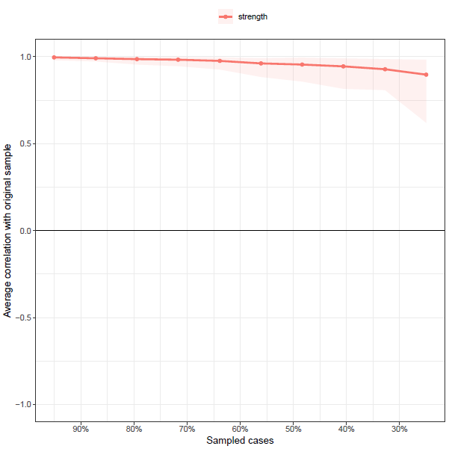

pdf("ExpectStability3.pdf")

plot(b6, “expectedInfluence”)

dev.off()

pdf("betweenStability3.pdf")

plot(b6, "betweenness")  
dev.off()

pdf("closeStability3.pdf")

plot(b6, "closeness")

dev.off()

#Strength Centrality Diff Tests, saved as pdf

pdf("CentralityDifference3.pdf")

plot(b5, "strength", order="sample", labels=TRUE)

dev.off()

#Expected INfluence stability graph saved as pdf - Unneccessary

pdf("EIdifference3.pdf")

plot(b5, "expectedInfluence", order="sample", labels=TRUE)

dev.off()

#Edge Stability Graph saved as pdf

pdf("EdgeStability3.pdf")

plot(b5, labels = FALSE, order = "sample")

dev.off()

#Edge weights stability test saved as pdf

pdf("EdgeDifftest3.pdf")

plot(b5, "edge", plot="difference", onlyNonZero=TRUE, order = "sample")

dev.off()

#Save plot as a pdf with groups into set directory

pdf("plot3.pdf")

plot3 <- plot(network3, layout="spring", vsize=6, border.color="black", groups=groups2, color=c('lightblue', 'orange'))

dev.off()

#create centrality plot and save as pdf

pdf("CentralityPlot3.pdf", width=5)

c3 <- centralityPlot(plot3)

dev.off()

#Create Expected influence plot and save as pdf (Unnecessary given the lack of negative edges)

pdf("ExpectedInfluence3.pdf", width=5)

e3 <- centralityPlot(plot3, include = "ExpectedInfluence")

dev.off()

#Create Betweenness/Closeness plot and save as a pdf.

pdf("BetClosePlot3.pdf", width=5)

c3 <- centralityPlot(network3, include = c("Betweenness", "Closeness"), orderBy ="default")

dev.off()

#save centrality values as a excel file

Centrality3 <- centralityTable(network3)

write.csv(Centrality3, "Centrality3.csv")

|  |  |  |  |  |  |
| --- | --- | --- | --- | --- | --- |
|  | graph | type | node | measure | value |
| 1 | graph 1 | NA | CAS1_3 | Betweenness | -0.97503 |
| 2 | graph 1 | NA | CAS2_3 | Betweenness | -0.97503 |
| 3 | graph 1 | NA | CAS3_3 | Betweenness | 0.487515 |
| 4 | graph 1 | NA | CAS4_3 | Betweenness | -0.97503 |
| 5 | graph 1 | NA | CAS5_3 | Betweenness | 1.365042 |
| 6 | graph 1 | NA | Depression3 | Betweenness | 0.780024 |
| 7 | graph 1 | NA | Anxiety3 | Betweenness | 1.218787 |
| 8 | graph 1 | NA | Stress3 | Betweenness | 0.048751 |
| 9 | graph 1 | NA | Alcoholism3 | Betweenness | -0.97503 |
| 10 | graph 1 | NA | CAS1_3 | Closeness | -0.31277 |
| 11 | graph 1 | NA | CAS2_3 | Closeness | -0.26971 |
| 12 | graph 1 | NA | CAS3_3 | Closeness | 0.471846 |
| 13 | graph 1 | NA | CAS4_3 | Closeness | 0.42326 |
| 14 | graph 1 | NA | CAS5_3 | Closeness | 1.114956 |
| 15 | graph 1 | NA | Depression3 | Closeness | 0.31396 |
| 16 | graph 1 | NA | Anxiety3 | Closeness | 0.718479 |
| 17 | graph 1 | NA | Stress3 | Closeness | -0.10221 |
| 18 | graph 1 | NA | Alcoholism3 | Closeness | -2.35781 |
| 19 | graph 1 | NA | CAS1_3 | Strength | -6.98E-05 |
| 20 | graph 1 | NA | CAS2_3 | Strength | 0.099122 |
| 21 | graph 1 | NA | CAS3_3 | Strength | 1.005808 |
| 22 | graph 1 | NA | CAS4_3 | Strength | 0.301119 |
| 23 | graph 1 | NA | CAS5_3 | Strength | 0.761231 |
| 24 | graph 1 | NA | Depression3 | Strength | 0.480982 |
| 25 | graph 1 | NA | Anxiety3 | Strength | -0.12856 |
| 26 | graph 1 | NA | Stress3 | Strength | -0.05852 |
| 27 | graph 1 | NA | Alcoholism3 | Strength | -2.46111 |
| 28 | graph 1 | NA | CAS1_3 | ExpectedInfluence | 0.052902 |
| 29 | graph 1 | NA | CAS2_3 | ExpectedInfluence | 0.153214 |
| 30 | graph 1 | NA | CAS3_3 | ExpectedInfluence | 1.070143 |
| 31 | graph 1 | NA | CAS4_3 | ExpectedInfluence | 0.253691 |
| 32 | graph 1 | NA | CAS5_3 | ExpectedInfluence | 0.688226 |
| 33 | graph 1 | NA | Depression3 | ExpectedInfluence | 0.539388 |
| 34 | graph 1 | NA | Anxiety3 | ExpectedInfluence | -0.07704 |
| 35 | graph 1 | NA | Stress3 | ExpectedInfluence | -0.24458 |
| 36 | graph 1 | NA | Alcoholism3 | ExpectedInfluence | -2.43594 |

#construct a partial correlation matrix

Edges3<-getWmat(network3)

write.csv(edges3, "edges3.csv")

|  |  |  |  |  |  |  |  |  |  |
| --- | --- | --- | --- | --- | --- | --- | --- | --- | --- |
|  | CAS1_3 | CAS2_3 | CAS3_3 | CAS4_3 | CAS5_3 | Depression3 | Anxiety3 | Stress3 | Alcoholism3 |
| CAS1_3 | 0 | 0.236718 | 0.310971 | 0.174051 | 0.065088 | 0.018041 | 0.031487 | 0 | 0 |
| CAS2_3 | 0.236718 | 0 | 0.356667 | 0.141678 | 0.127407 | 0.003534 | 0 | 0 | 0 |
| CAS3_3 | 0.310971 | 0.356667 | 0 | 0.178988 | 0.269541 | 0.008506 | 0.012344 | 0 | 0 |
| CAS4_3 | 0.174051 | 0.141678 | 0.178988 | 0 | 0.394346 | 0 | 0 | -0.01534 | 0.021979 |
| CAS5_3 | 0.065088 | 0.127407 | 0.269541 | 0.394346 | 0 | 0 | 0.163361 | -0.01989 | 0.024281 |
| Depression3 | 0.018041 | 0.003534 | 0.008506 | 0 | 0 | 0 | 0.405821 | 0.544244 | 0 |
| Anxiety3 | 0.031487 | 0 | 0.012344 | 0 | 0.163361 | 0.405821 | 0 | 0.184937 | 0 |
| Stress3 | 0 | 0 | 0 | -0.01534 | -0.01989 | 0.544244 | 0.184937 | 0 | 0.054476 |
| Alcoholism3 | 0 | 0 | 0 | 0.021979 | 0.024281 | 0 | 0 | 0.054476 | 0 |

#Estimate bridge Values for each node

bridge(plot3, communities=c('1', '1', '1', '1', '1', '2', '2', '2', '2'), useCommunities = "all", directed = NULL, nodes = NULL)

$`Bridge Strength`

CAS1_3 CAS2_3 CAS3_3 CAS4_3 CAS5_3 Depression3

0.049527212 0.003533604 0.020849560 0.037319244 0.207529999 0.030080219

Anxiety3 Stress3 Alcoholism3

0.207190897 0.035228264 0.046260240

$`Bridge Betweenness`

CAS1_3 CAS2_3 CAS3_3 CAS4_3 CAS5_3 Depression3

0 0 8 0 16 10

Anxiety3 Stress3 Alcoholism3

15 5 0

$`Bridge Closeness`

CAS1_3 CAS2_3 CAS3_3 CAS4_3 CAS5_3 Depression3

0.04901209 0.05002216 0.05818215 0.06244831 0.07419831 0.07985542

Anxiety3 Stress3 Alcoholism3

0.09941852 0.06963767 0.03056544

$`Bridge Expected Influence (1-step)`

CAS1_3 CAS2_3 CAS3_3 CAS4_3 CAS5_3

0.049527212 0.003533604 0.020849560 0.006639036 0.167753680

Depression3 Anxiety3 Stress3 Alcoholism3

0.030080219 0.207190897 -0.035228264 0.046260240

$`Bridge Expected Influence (2-step)`

CAS1_3 CAS2_3 CAS3_3 CAS4_3 CAS5_3 Depression3

0.10466221 0.04836477 0.09928962 0.07482061 0.26190925 0.12172640

Anxiety3 Stress3 Alcoholism3

0.39133428 -0.00869009 0.08467587

#Set Bridge estimates as an object

bridge3 <- bridge(plot3, communities=c('1', '1', '1', '1', '1', '2', '2', '2', '2'), useCommunities = "all", directed = NULL, nodes = NULL)

#Create bridge expected influence graph and save as a pdf

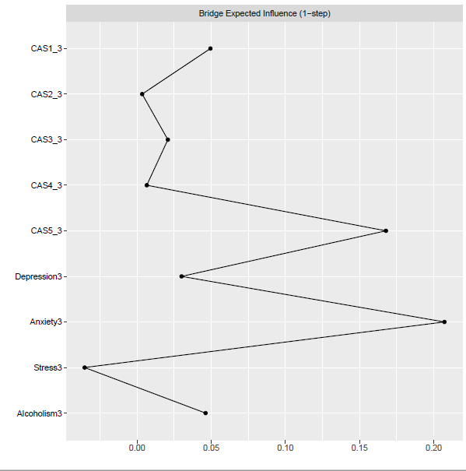pdf("bridgeEI3.pdf, width=5")

plot(bridge3, include = "Bridge Expected Influence (1-step)", width = 5)

dev.off()

#Create an object for the Stability estimates of bridges

bridgestability3 <- bootnet(network3, boots=1000, type="case", statistics=c("bridgeStrength", "bridgeExpectedInfluence", "bridgeBetweenness", "bridgeCloseness"), communities=groups2)

#get stability coefficients of that networks bridges

corStability(bridgestability3)

Maximum drop proportions to retain correlation of 0.7 in at least 95% of the samples:

bridgeBetweenness: 0.283

- For more accuracy, run bootnet(..., caseMin = 0.206, caseMax = 0.362)

bridgeCloseness: 0.439

- For more accuracy, run bootnet(..., caseMin = 0.362, caseMax = 0.517)

bridgeExpectedInfluence: 0.439

- For more accuracy, run bootnet(..., caseMin = 0.362, caseMax = 0.517)

bridgeStrength: 0.362

- For more accuracy, run bootnet(..., caseMin = 0.283, caseMax = 0.439)

Accuracy can also be increased by increasing both 'nBoots' and 'caseN'.

Part 4: Comparison

#Now let's compare the two networks we've created.

#Omit missing data from datasets

newdata1 <- na.omit(Time1)

newdata2 <- na.omit(Time2)  
newdata3 <- na.omit(Time3)

#Create names for nodes in the networks  
names <- c("CAS1", "CAS2", "CAS3", "CAS4", "CAS5", "Depression", "Anxiety", "Stress", "Alcoholism")

names2 <- c("CAS1_2", "CAS2_2", "CAS3_2", "CAS4_2", "CAS5_2", "Depression2", "Anxiety2", "Stress2", "Alcoholism2")

names3 <- c("CAS1_3", "CAS2_3", "CAS3_3", "CAS4_3", "CAS5_3", "Depression3", "Anxiety3", "Stress3", "Alcoholism3")

#Estimate networks from these new datasets

networkc1 <- estimateNetwork(newdata1, default="EBICglasso")

networkc2 <- estimateNetwork(newdata2, default="EBICglasso")

networkc3 <- estimateNetwork(newdata3, default="EBICglasso")

#Run the NCT between time point 1 and 2

Comparison <- NCT(networkc1, networkc2, it=1000, weighted = TRUE, test.edges = FALSE, edges='ALL')

#Run the NCT between time point 1 and 3

Comparison2 <- NCT(networkc1, networkc3, it=1000, weighted = TRUE, test.edges = FALSE, edges='ALL')

#Run the NCT between time point 2 and 3

Comparison3 <- NCT(networkc2, networkc3, it=1000, weighted = TRUE, test.edges = FALSE, edges='ALL')

#Get the results of the NCT between time point 1 and 2

summary(Comparison)

NETWORK INVARIANCE TEST

Test statistic M: 0.4213884

p-value 0

GLOBAL STRENGTH INVARIANCE TEST

Global strength per group: 3.799512 3.542014

Test statistic S: 0.2574981

p-value 0.22

EDGE INVARIANCE TEST

Edges tested:

Test statistic E:

p-value

CENTRALITY INVARIANCE TEST

Nodes tested:

Centralities tested:

Test statistic C:

p-value

#Get the results of the NCT between time point 1 and 3

summary(Comparison2)

NETWORK INVARIANCE TEST

Test statistic M: 0.1608492

p-value 0.736

GLOBAL STRENGTH INVARIANCE TEST

Global strength per group: 3.799512 3.763693

Test statistic S: 0.03581892

p-value 0.895

EDGE INVARIANCE TEST

Edges tested:

Test statistic E:

p-value

CENTRALITY INVARIANCE TEST

Nodes tested:

Centralities tested:

Test statistic C:

p-value

#Get the results of the NCT between time point 2 and 3

summary(Comparison3)

NETWORK INVARIANCE TEST

Test statistic M: 0.2605392

p-value 0.476

GLOBAL STRENGTH INVARIANCE TEST

Global strength per group: 3.542014 3.763693

Test statistic S: 0.2216792

p-value 0.391

EDGE INVARIANCE TEST

Edges tested:

Test statistic E:

p-value

CENTRALITY INVARIANCE TEST

Nodes tested:

Centralities tested:

Test statistic C:

p-value